

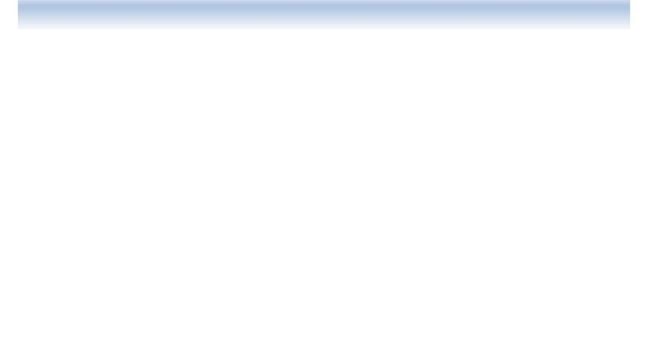

**Sanchez, Sergio Sebastian**

**C++/C#/.NET Framework Programmer**

- Second-year student of the University Technician Degree in Programming- UTN FRGP

- Intermediate English Level B1

- Portfolio: https://sergiosebs2.github.io/portfolio-pagina

- LinkedIn: linkedin.com/in/sergio-sanchez-29183a22a

- Email: sergiosebs14@gmail.com



## ecundario Completo

**Professional Profile**

I am a highly motivated systems student with a strong technical background. I am passionate about continuous learning and personal improvement. Although I do not have formal work experience in programming, I have developed my own projects that have strengthened my practical skills. I currently work in a plastic packaging production factory. Additionally, I have diverse work experience in different fields, which has allowed me to develop a strong work ethic, teamwork skills, and excellent interpersonal relationships. Furthermore, I am improving my English to expand my professional opportunities.

**EDUCATION:**

* High School Diploma
* Electromechanical Technician

**Professional Objetives**

My goal is to enter the technology field as a programmer, where I can apply and expand my knowledge in challenging and collaborative environments. I am determined to continue my education and contribute innovative solutions that drive growth and efficiency in organizations. I aspire to work on projects that allow me to grow professionally while adding value to my team and surroundings.

* PC and Network Repair Technician (Educentro)

**SKILLS:** TEAMWORK || RESPONSIBILITY || ADAPTABILITY ||

EFFECTIVE COMMUNICATION|| PROBLEM SOLVING

* TUP UTN FRGP (in progress)
* English B1 Level 4 (Celc Idiomas, in progress)
* Oracle ONE Program
* Java Course (Partes Informáticas)
* Spring Boot with Java Course (Todo Code Academy)

**TECHNICAL SKILLS:**

* Structured and Object-Oriented Programming in:

**C++ / C# / JAVA**

* .Net Framework
* GitHub
* MySQL
* SQL Server
* HTML, CSS, JS